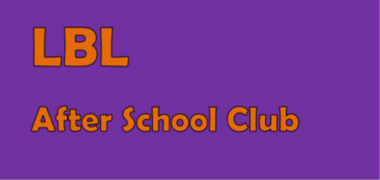
LBL Coppetts Wood After School Club: Registration Form

Full name of child: _______________________
Parent details
Parent’s name:

Address:

Telephone home:

Telephone work:

Mobile number:

Email address:

Relationship to child:

Child details
Gender:

Date of birth:

Illness/Conditions/Food Intolerances/Medically advised allergies:

Any other information you feel may be relevant for staff:

I agree for the staff at LBL to administer first aid where appropriate and in emergency situations to administer paracetamol-based medicine (for sudden very high temperatures) or Piriton (for unexpected allergic reactions). YES/NO
I agree that staff may deal with changing or assisting my child with changing in the event of them soiling or wetting their clothes. YES/NO
Password in the event that my child is collected by someone other than a parent or regular carer: _______________________

I agree to pay any invoiced fees promptly and understand there are fees for late payment and fees for collecting my child beyond the closing time of 5:45pm.
By completing this form I agree for my child to attend LBL After School Club and abide by all the policies set out on the website in order to for the staff to maintain a safe, healthy and fun environment for the children.
Signed: _______________________________________ Date:______________________

