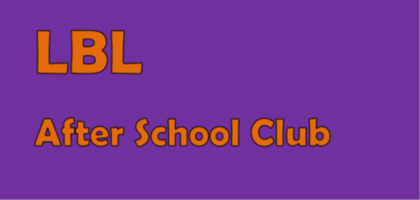
LBL After School Club: Registration Form

Full name of child: _______________________
Parent details
Parent’s name:

Address:

Telephone home:

Telephone work:

Mobile number:

Email address:

Relationship to child:

Child details
Gender:

Date of birth:

Religion:

Illness/Conditions/Food Intolerances/Medically advised allergies:

Any other information you feel may be relevant for staff:

I agree for the staff at LBL to administer first aid where appropriate and in emergency situations to administer paracetamol-based medicine (for sudden very high temperatures) or Piriton (for unexpected allergic reactions). YES/NO
I agree that staff may deal with changing or assisting my child with changing in the event of them soiling or wetting their clothes. YES/NO
Password in the event that my child is collected by someone other than a parent or regular carer: _______________________

I agree to pay any invoiced fees promptly and understand there are fees for late payment and fees for collecting my child beyond the closing time of 6pm.
By completing this form I agree for my child to attend LBL After School Club and abide by all the policies set out on the website in order to for the staff to maintain a safe, healthy and fun environment for the children.
Signed: _______________________________________ Date:______________________

